Chapter 3, Problem 29.

Use MATLAB to solve for the node voltages in the circuit of Fig. 3.78.

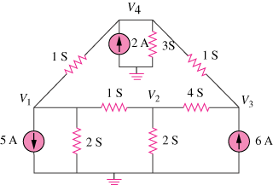

Figure 3.78
For Prob. 3.29.

